Jose

PastelTech

Pasteltech light sensor Tutorial

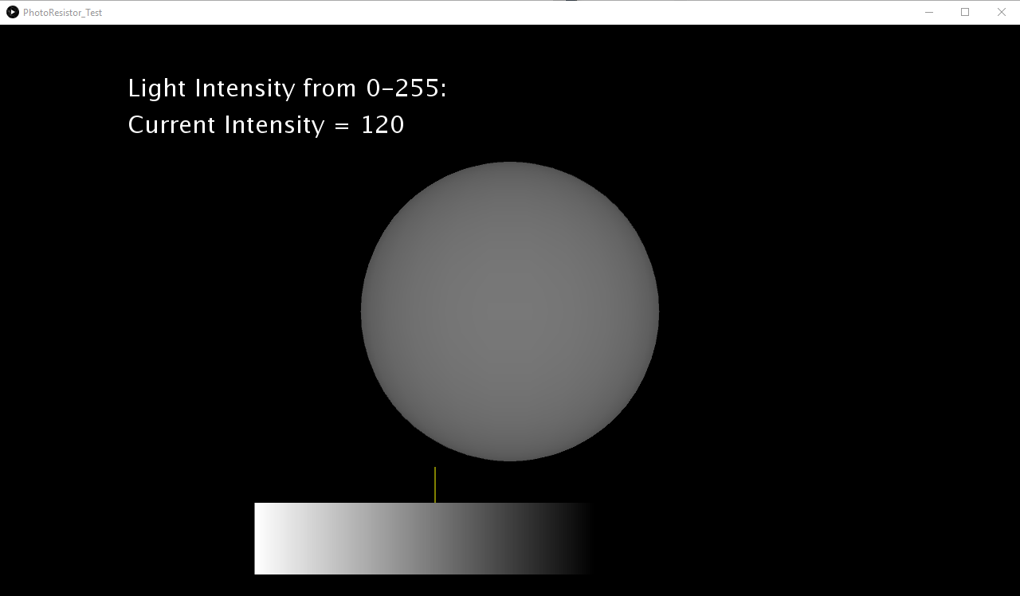

# Pasteltech light sensor tutorial

## This tutorial calculates the light intensity from a scale of 0 to 255 by using the pasteltech board’s analog input pins. it then sends the data to be read by a processing sketch that applies the light intensity to visual data elements.

*Uses Arduino IDE

*Uses Processing IDE

The following components will be used:

* 1 PhotoResistor
* 4 Male to Male 20cm Jumper Wires
* 1 1/4W 10k Ohm Resistor
* 1 400 Point Breadboard
* 1 PastelTech Uno Arduino Compatible
* 1 USB B Cable
* Water and some snacks

# Components Explained:

* What is a PhotoResistor?

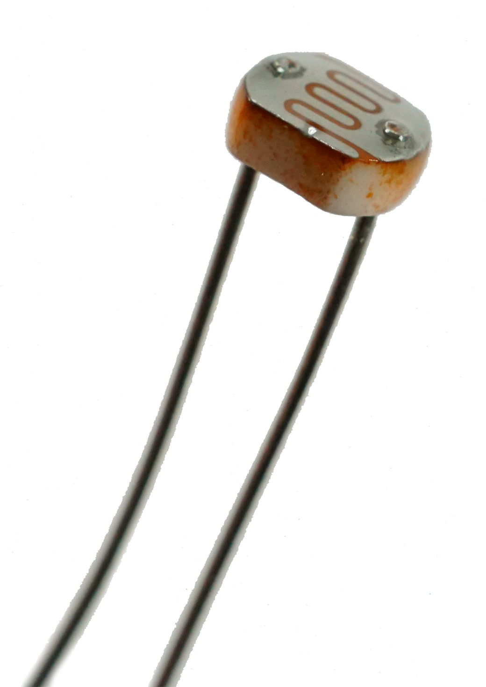

* + A photoresistor is a resistor that is made with a semi-conductor like material. With increasing luminance, its conductance changes.
  + Some uses for a photoresistor are in smartphones. It can be used to increase the screen brightness if you go outside or decrease the brightness when the ambient light is low.
  + For this sensor the peak spectrum value is around the green range, so green light will activate more than other light sources.

# How does the code work?

*the sensor can also be used as a rudimentary touch switch, when a finger is on the sensor, it approaches a value of 0, if the value is under 30, a touch can be detected, then Serial.print(“Touch”);*

# Arduino code overview

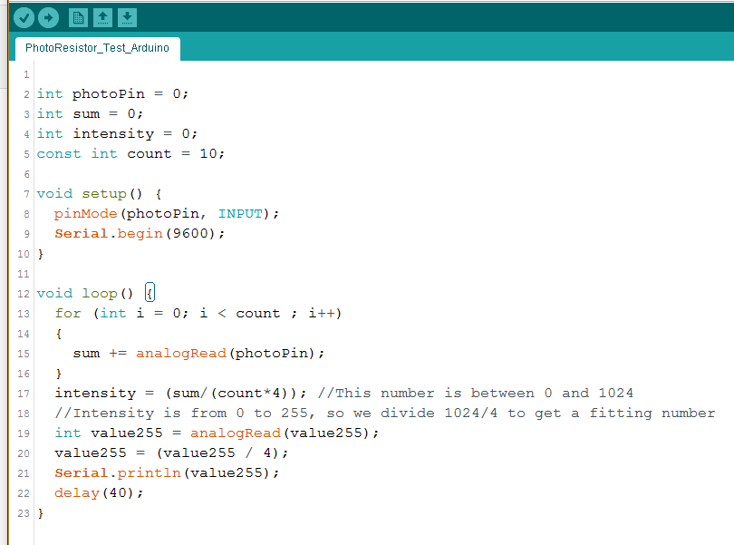

* Line 2: Here we set Analog Pin 0 (A0) as the photoResistor pin
* Lines 3-5: We create a sum int, intensity and count, the count is used to create an average of 10 values that are then sent out as the average value.
* Lines 7-10: we setup the Analog pin as an INPUT and begin the serial monitor, press ctrl+shift+m to access (Make sure baud rate is set to 9600 on both)
* Lines 13-16: We have the for loop finding the sum of 10 values by accessing the analogRead value of the photoPin(A0)
* Line 17: Intensity is calculated from 0 to 1024
* Line 19-21: We calculated a new value from 0 to 255 using intensity, we then print it to the serial monitor
* Line 22: We delay for 40 milliseconds, use this to change how often the Arduino code sends out new values.

# Pasteltech code overview

* The processing code reads the serial monitor data from the Arduino and displays a gradient bar, showing the range from 0 to 255 of gray values that represent the light intensity. A sphere is also drawn showing the gray value from 0 to 255.